Machine Description | DC-7 is a vulnerable Linux web server running Joomla 3.7.0 with a known SQL injection flaw. The machine is designed to simulate a real-world CMS compromise where an attacker exploits the Joomla vulnerability to gain admin access, upload a malicious shell, and escalate to full system control.
Target IP | 10.136.108.35
Vulnerability Name | Joomla Core 3.7.0 SQL Injection leading to admin takeover and PHP code execution.
Service / Version | TCP / 80 HTTP
CVSS Score / Severity | 9.8 Critical
Attack Vector | AV:N/AC:L/PR:N/UI:N/S:U/C:H/I:H/A:H
Proof Of Concept | STEP 1 – Discover the target IP address using netdiscover tool  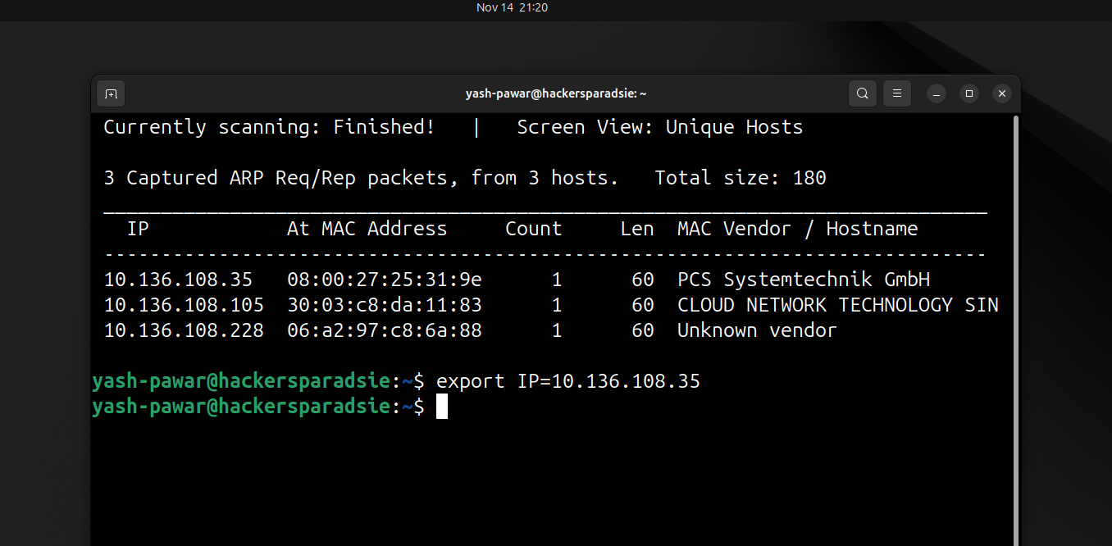  STEP 2 – Scan for the open ports and services on the target system using nmap  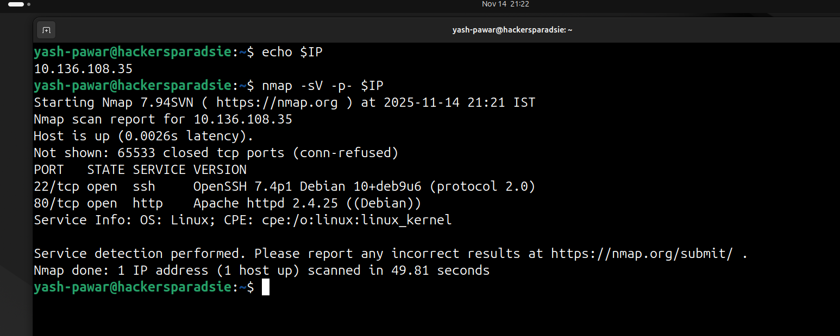  - Here we got 22 SSH and 80 HTTP open on target system  STEP 3 – Enumerating HTTP 80  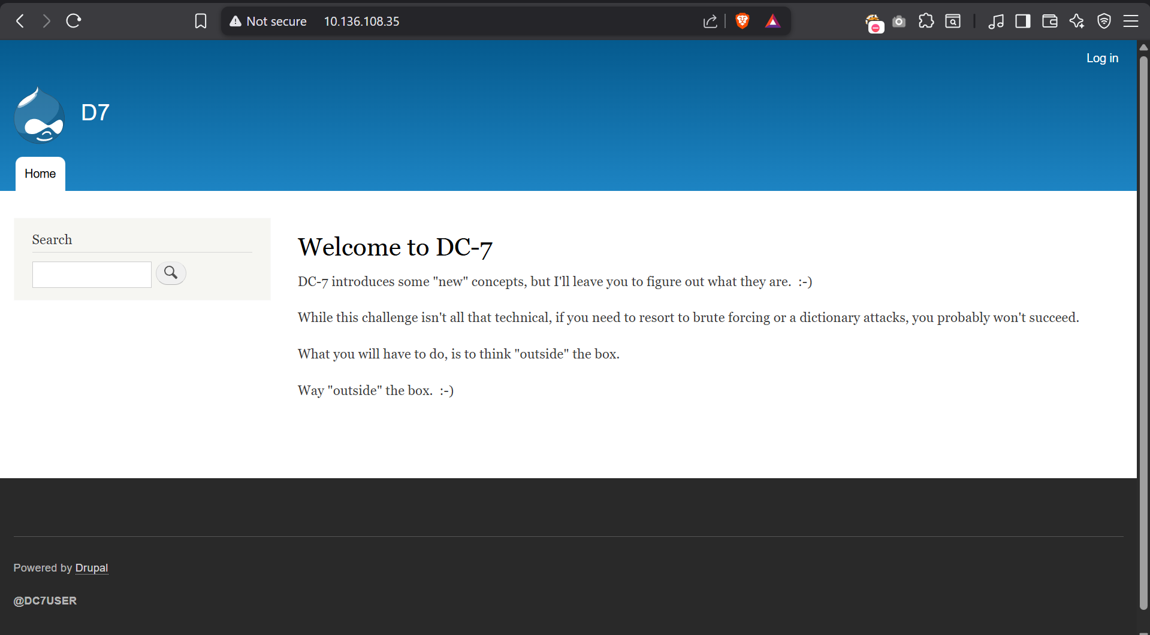  - We have Drupal CMS running on the target SYSTEM lets look for the files and directories on server in robots.txt  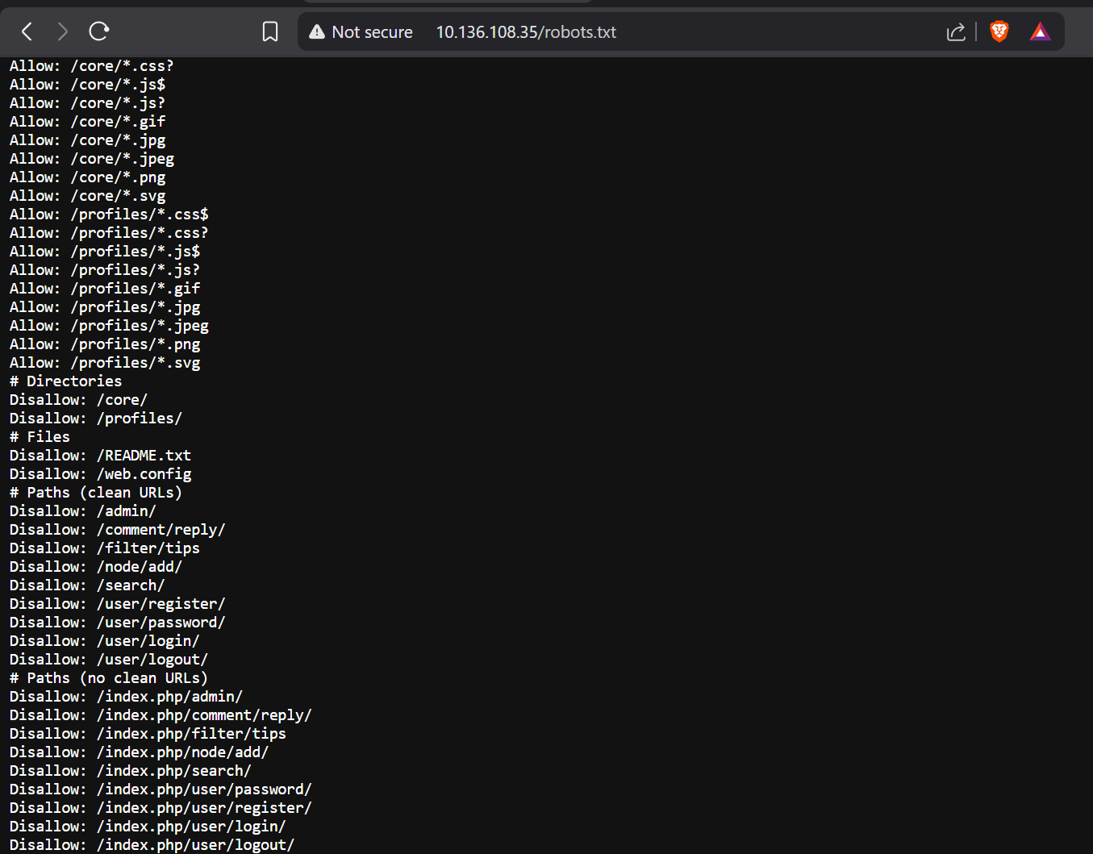  - We have some information from robots.txt  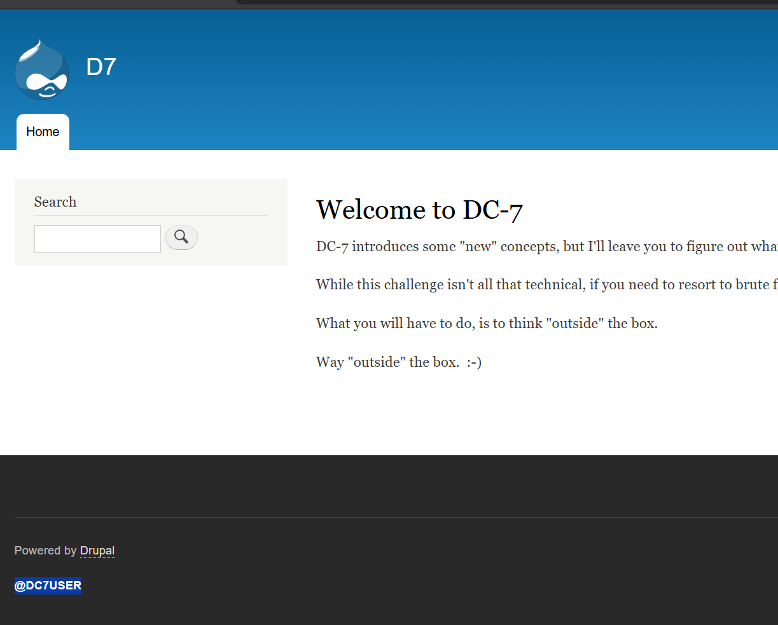  We also haver username her lets find some information on internet related to it  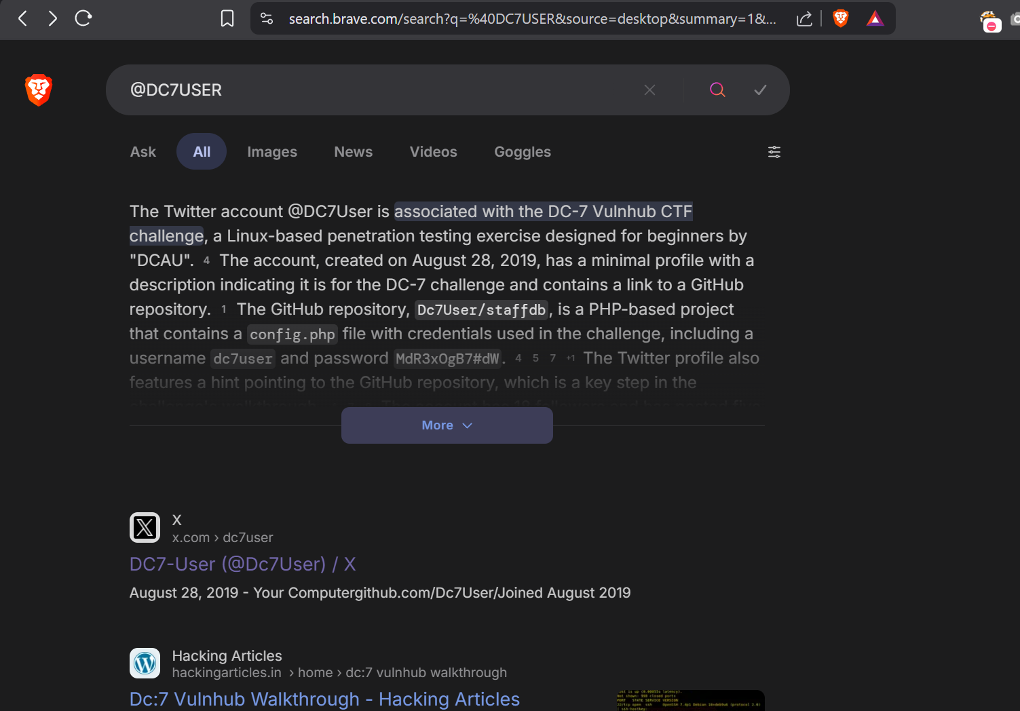  - We have twitter account for relevant username  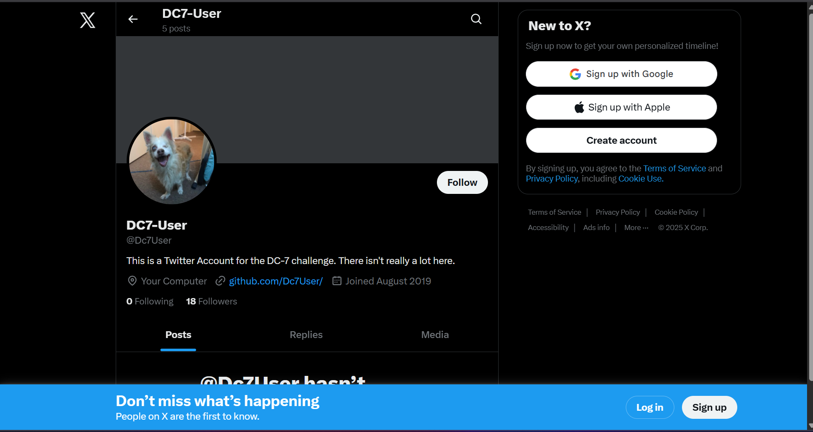  Here we have some kind of link in the bio of user related to github repo lets visit  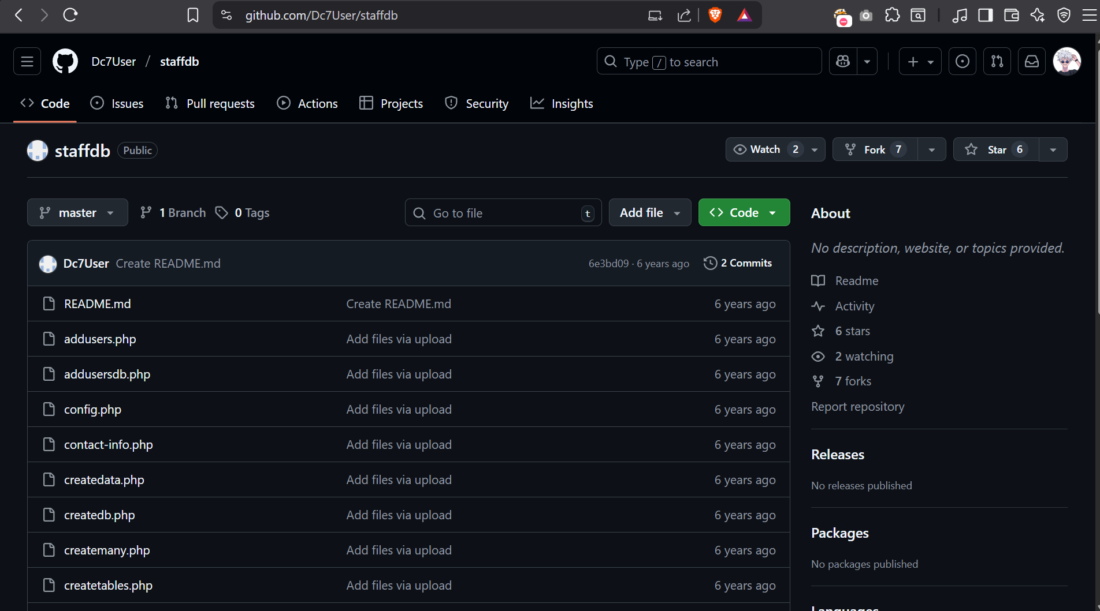  Got user full content related to target machine  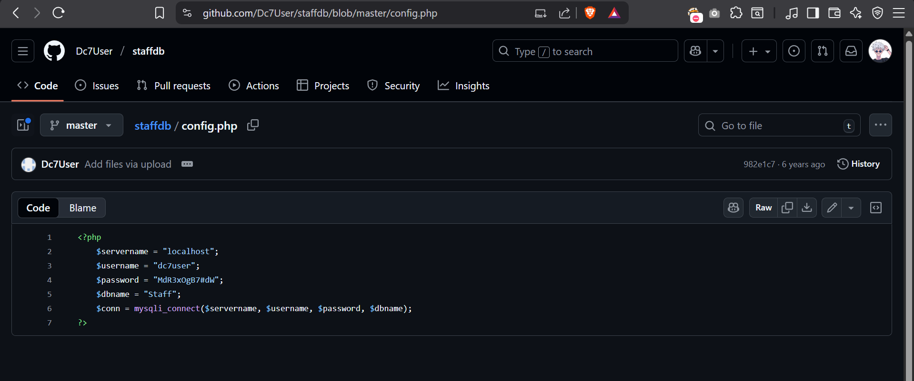  We have here one user and password related to it  STEP 4 – Lets try to authenticate user using credentials we got using ssh service  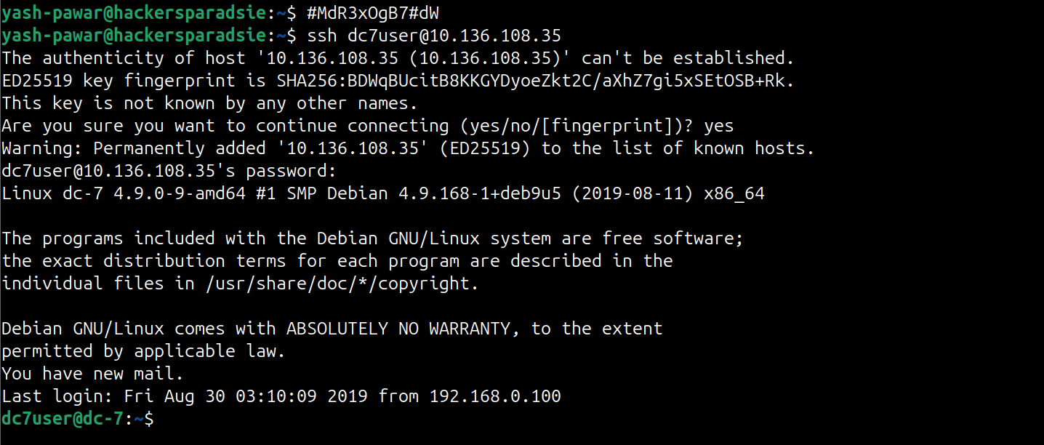  - We have valid login on the target System  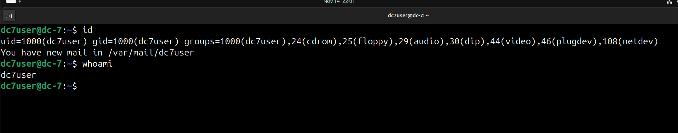  STEP 5 – Let’s Enumerate here further  - We have mail here  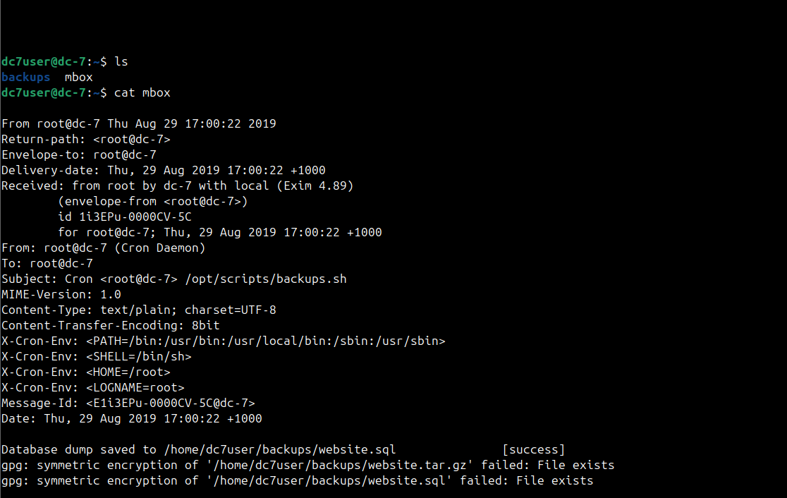  - Note its some cronjob running some kind of script backup.sh  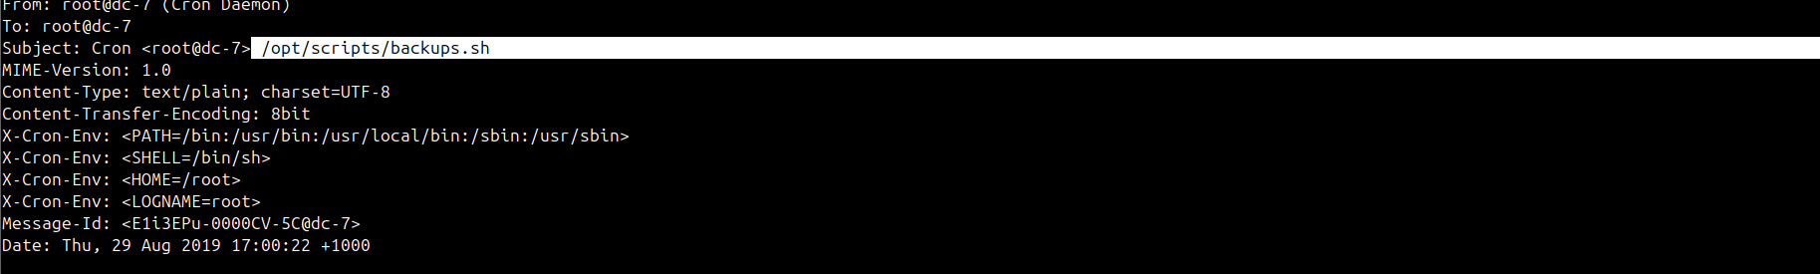  - It has this content  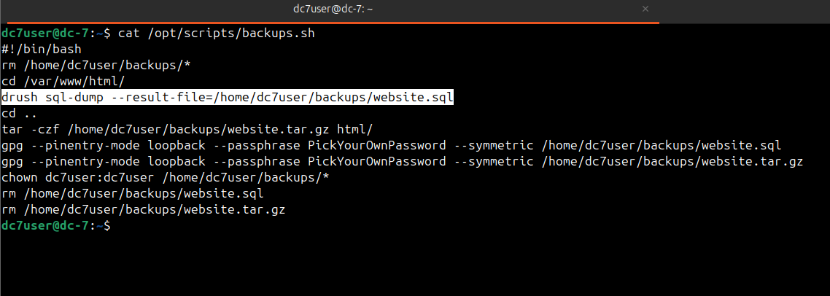  - we notice it is using drush which stands for Drupal shell and it is a command-line utility that is used to communicate with drupal CMS.  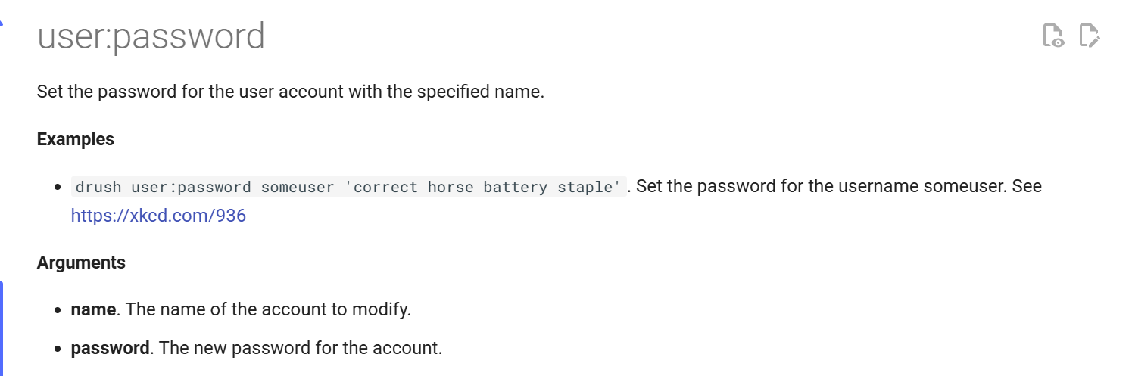  - we try to change the admin password  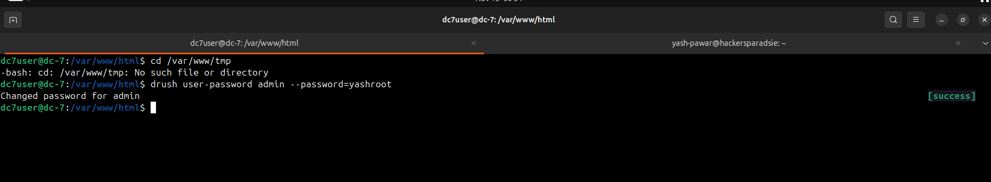  - we tried to authenticate here  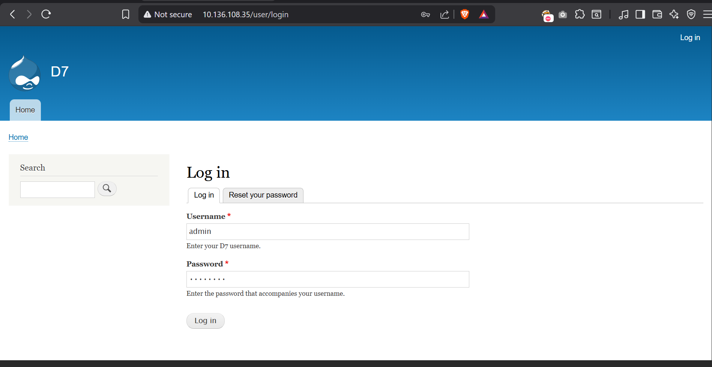  - Got login on CMS  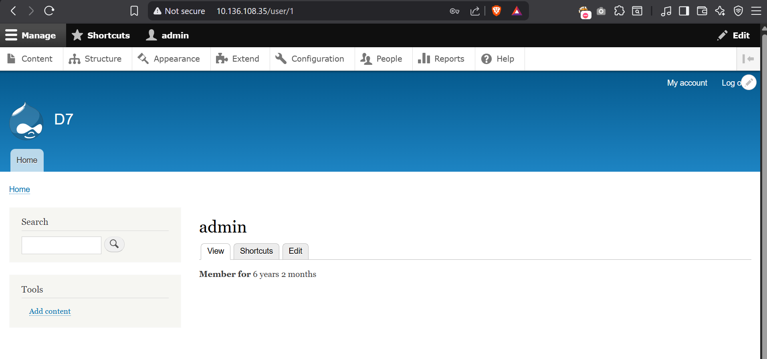
Impact | - Attacker can extract Joomla admin credentials through SQL injection.  - Admin compromise leads to arbitrary PHP upload and full RCE.  - Complete takeover of the web application and underlying server.  - Data theft, defacement, service disruption, and persistence possible.
Remediation | - Update Joomla to 3.7.1 or later, which patches the SQL injection flaw.  - Implement prepared statements and strict input validation in custom modules.  - Restrict admin panel access using IP allowlisting and strong passwords.  - Enable regular patch cycles and disable unused Joomla extensions
Reference | - CVE Record :  https://nvd.nist.gov/vuln/detail/CVE-2017-8917  - MITRE :  https://cve.mitre.org/cgi-bin/cvename.cgi?name=CVE-2017-8917  - Joomla Security Advisory :  https://developer.joomla.org/security-centre/697-20170501-core-sql-injection.html

